SYSTEMS DIVISION

IPD PDS
TEST PLAN DOCUMENT
WR # 2111

DRAFT

Prepared By:
Back Office IPD Team

1. PDS File creation test 4
1.1. PDS file creation test 4
1.1.1. Test Description: 4
1.1.2. Test Environment 4
1.1.3. Expected Results 4
1.1.4. Actual Results 4

PDS FILE CREATION Test

PDS File Creation Test

Test Description:
The PDS file to be reconciled resides on the MVS system. It should be copied to DASD for the verification. The DSN is CBOE.SC.SRTDTSS.SERIES(0) or whatever generation is appropriate. The tester will need an MVS logon to do this. Even if IPD is reconciled to TPF there may be manual changes from TPF that are reflected in the production PDS file such as changes to reporting classes and extra deletes.
The following script will be used to create the PDS series file: createPdsFile. The series file FTPd to MVS is TS333ID.CBOE.SC.SRTDTSS.SERIES. If the next trading day desired is not the one on the table bus_day an extra program parameter can be added at the end of the execution line in the form YYMMDD (i.e. 050823) so that the proper day can be processed and the results compared against the production copy.

Test Environment
IPD and ipdsd000 and MVS.

Expected Results
- Compare is TS333ID.CBOE.SC.SRTDTSS.SERIES with is CBOE.SC.SRTDTSS.SERIES(0) or whatever generation is appropriate. These files should be identical.

Actual Results
The data in the MVS files.
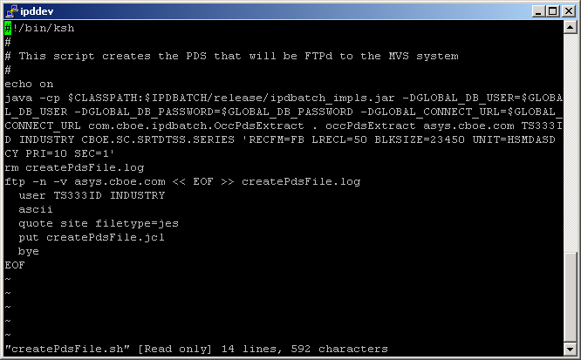

This is the unix script createPdsFile.sh. The default next trading day is obtained from the table bus_day. If another trading day is needed it can be added to the end of the execution line in YYMMDD format, for example 050823. This script will create the unix file occPdsExtract that will be FTPd to MVS with the names TS333ID.CBOE.SC.STRDTSS.SERIES.

